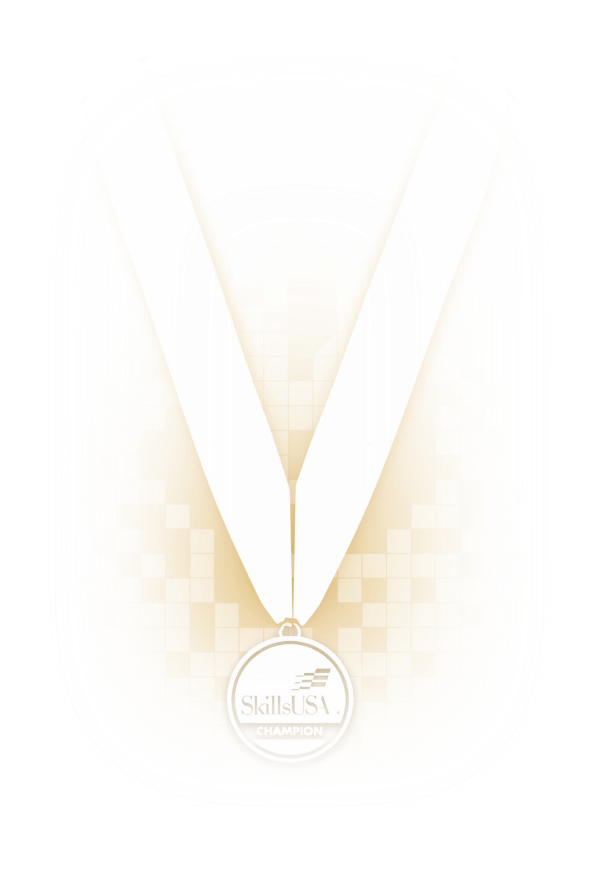

CLOTHING CLASSIFICATIONS

(with photos)
These regulations refer to clothing items that are pictured and described at www.skillsusastore.org. If you have questions about clothing or other logo items, call 1-888-501-2183.

Clothing Addendum to National SkillsUSA Technical Standards for Kentucky State Contests (see highlighted areas)
- Judges will accept official SkillsUSA dress OR clothing that meets the criteria below for regional and state contests in Kentucky.

- Official SkillsUSA dress may be replaced by similar items without logos.
- For example, the white SkillsUSA polo may be replaced by a white polo that has no logo or branding.
- For example, the blue SkillsUSA shirt (required in Automotive Service Technology and other such contests) can be replaced by a light blue button-up shirt that has no logo or branding.

- Shoes, socks and belt requirements remain the same.
- Clothing must be clean and free from holes and tears.

NOTE: Official dress is still required for the state conference Opening and Closing sessions. Remember that red jackets, black Carhart blazers and wind breakers that have the VICA, SkillsUSA/VICA or SkillsUSA emblem still qualify as official dress.
BE ADVISED that this addendum does NOT change the requirement for students to wear official SkillsUSA clothing for national conference.

CLASS A: SKILLSUSA ATTIRE
- Official SkillsUSA red blazer or official SkillsUSA red jacket
- Button-up, collared, white dress shirt (accompanied by a plain, solid black tie or SkillsUSA black tie), white shirt (collarless or small-collared) or white turtleneck, with any collar not to extend into the lapel area of the blazer, sweater, windbreaker or jacket
- Black dress slacks or black dress skirt (knee-length at minimum)
- Black dress shoes
Note: The official SkillsUSA windbreaker, sweater and black Carhartt jacket are no longer available for purchase in the SkillsUSA Store. However, these clothing items are grandfathered in as previous official SkillsUSA clothing and can be worn in SkillsUSA competitions as directed in this document.

Note: Wearing socks or hose is no longer required. If worn, socks must be black dress socks and hose must be either black or skin-tone and seamless/nonpattern.

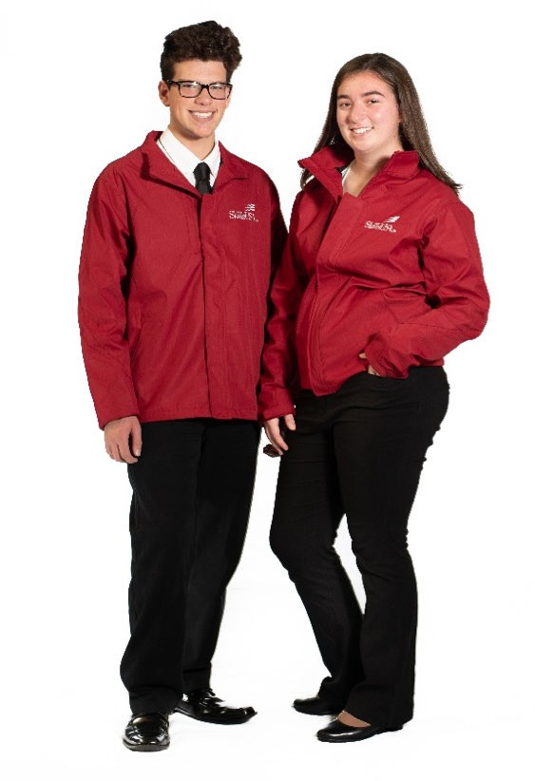
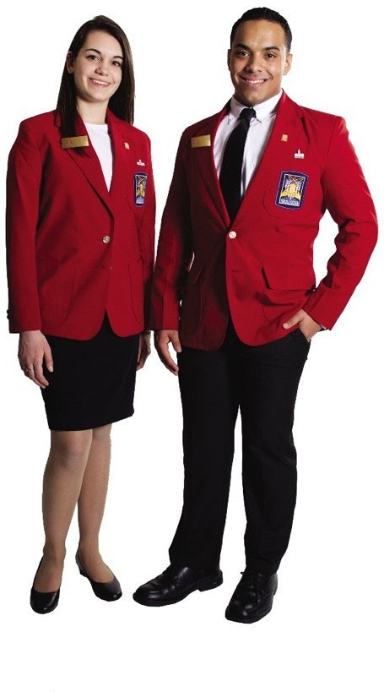
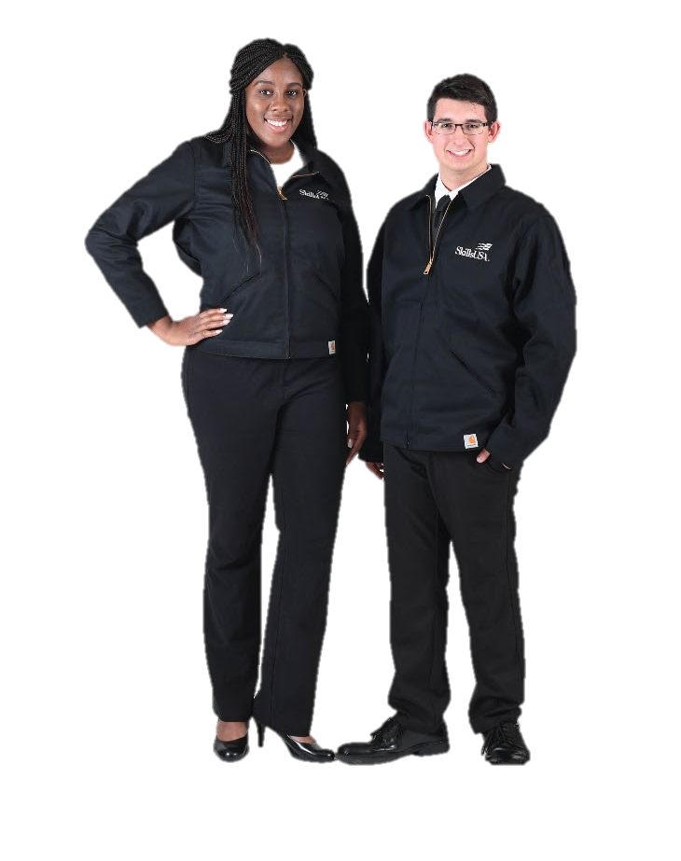

CLASS B: HEALTHCARE ATTIRE
- Official SkillsUSA blue scrubs or blue scrubs without SkillsUSA or other logos
- White socks or white seamless/nonpattern hose visible above the top of the shoe
- Health-professionals white or black leather work shoe

Note: Scrubs should fit appropriately for all health competitions and should be properly hemmed and wrinkle-free. Only plain, white, collarless T-shirts may be worn underneath the scrubs. Hair must be pinned up and off the collar.

Note: Shoes must be all-white or black leather (no canvas/mesh) and completely enclosed (no open-toe or open-heel). Athletic-style shoes that meet the criteria are acceptable.

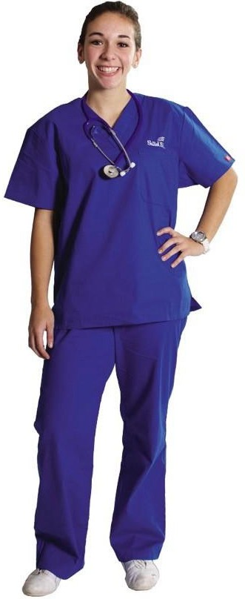

CLASS C: COMPETITION SPECIFIC — MANUFACTURING/CONSTRUCTION KHAKI ATTIRE
- Official SkillsUSA khaki short-sleeve work shirt
- Khaki pants or Khaki work shirt and pants without SkillsUSA or other logos
- Black, brown or tan leather work shoes
Note: Safety glasses must have side shields or goggles. (Prescription glasses may be used only if they are equipped with side shields. If not, they must be covered with goggles.)

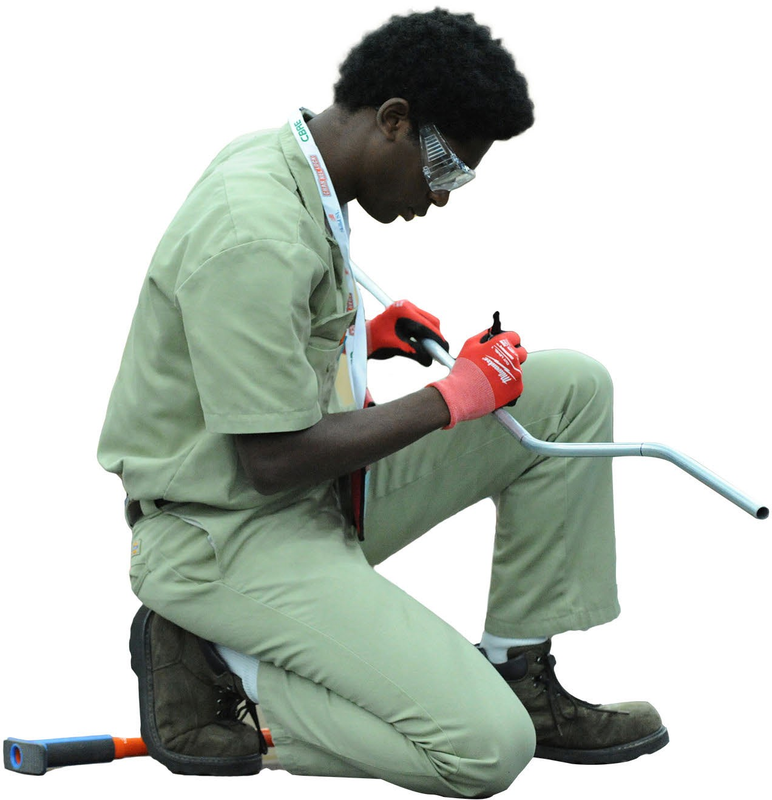

CLASS D: COMPETITION SPECIFIC — BLUE ATTIRE
- Official SkillsUSA light blue work shirt
- Navy pants or light blue work shirt; navy pants without SkillsUSA or other logos
- Black, brown or tan leather work safety shoes (with protective toe cap, unless otherwise specified in a competition technical standard).

Note: Safety glasses must have side shields or goggles. (Prescription glasses may be used only if they are equipped with side shields. If not, they must be covered with goggles.)

Note: Law and Public Safety cluster competitions have additional parameters listed in the technical standards that are specific to competition dress in these occupational areas.

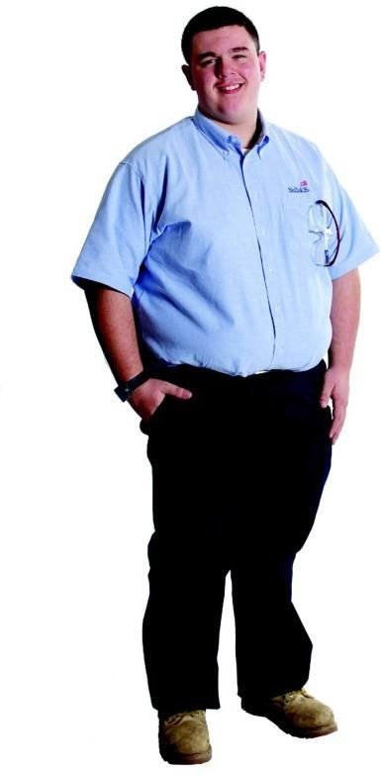
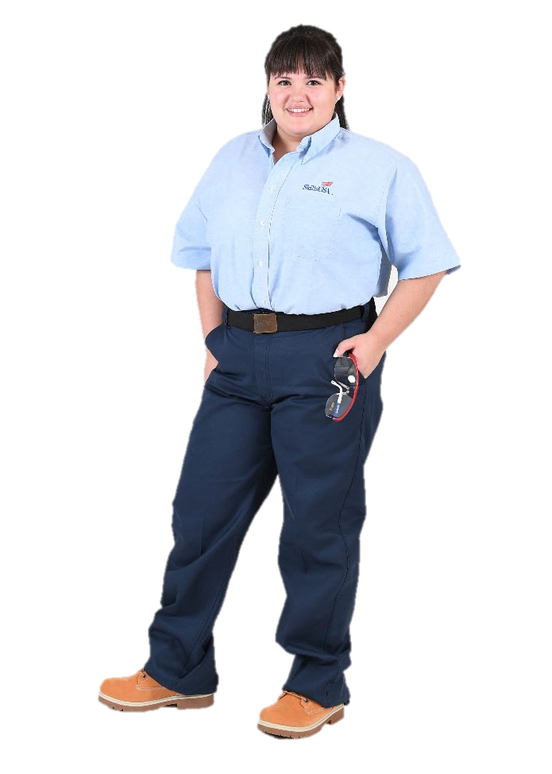

CLASS E: COMPETITION SPECIFIC — BUSINESS CASUAL
- Official SkillsUSA white polo shirt
- Black dress slacks or black dress skirt (knee-length minimum)
- Or white polo shirt; black dress slacks without SkillsUSA or other logos
- Or white polo shirt with black dress skirt (knee-length) or black slacks without SkillsUSA or other logos,
- Black closed-toe dress shoes

Note: Wearing socks or hose is no longer required. If worn, socks must be black dress socks and hose must be either black or skin-tone and seamless/nonpattern.

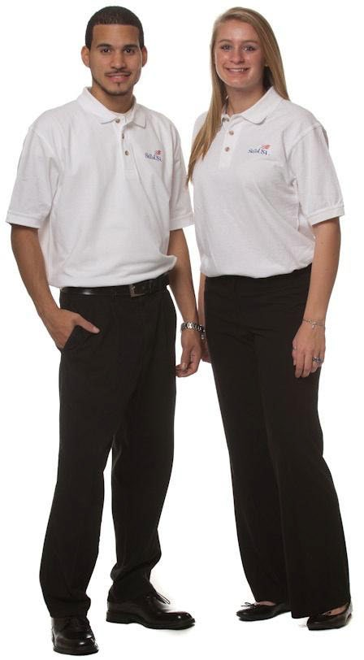

CLASS F: COMPETITION SPECIFIC — BARBERING, COSMETOLOGY, ESTHETICS, NAIL CARE
- Official SkillsUSA white dress shirt or official white polo
- Black dress slacks
- Or white dress shirt; black dress slacks without SkillsUSA or other logos;
- Or white top; black dress slacks without SkillsUSA or other logos;
- Black leather work or dress shoes
Note: Wearing socks or hose is no longer required. If worn, socks must be black dress socks and hose must be either black or skin-tone and seamless/nonpattern.

Note: The Official SkillsUSA white cosmetology smock or apron can be worn with the official white dress shirt.
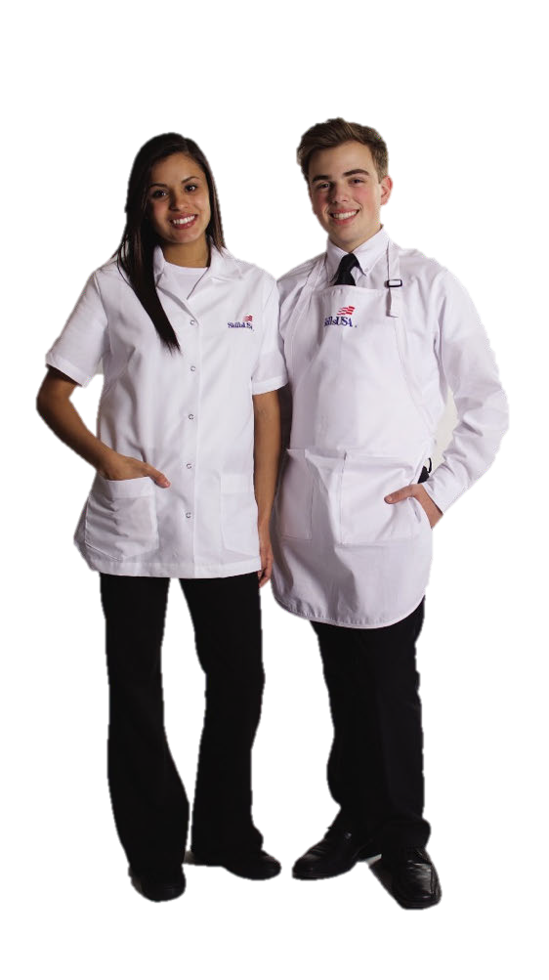

CLASS G: CULINARY/BAKING AND PASTRY ARTS ATTIRE
- White chef’s jacket OR white chef’s jacket Without SkillsUSA or other logos
- Black work pants or black-and-white checkered chef’s pants or White or black work pants or black-and-white checkered chef’s pants Without SkillsUSA or other logos
- Black non-slip, non-porous shoes
- White apron OR white apron Without SkillsUSA or other logos;
- Hair Restraint
Note: Chef’s hats (toques) and food handlers’ gloves will be supplied by the national technical committee.

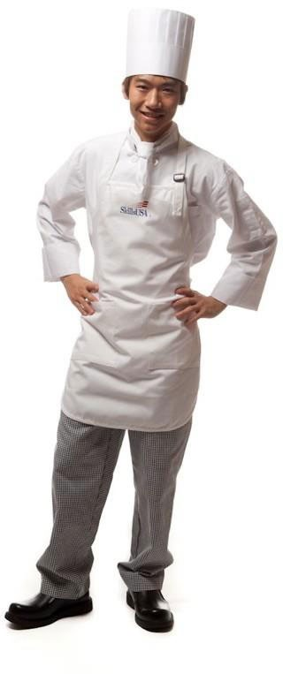

CLASS H: COMPETITION SPECIFIC — RESTAURANT SERVICE
- Official SkillsUSA white long-sleeved dress shirt, or long- sleeved plain white collared shirt
- Black dress slacks or black dress skirt (knee-length minimum)
- Plain black tie with no pattern or SkillsUSA black tie
- Official SkillsUSA bistro apron
- Shined black leather work shoes or black flat heels
- Note: The national guideline allow for non SkillsUSA logos on clothing.
Note: Wearing socks or hose is no longer required. If worn, socks must be black dress socks and hose must be either black or skin-tone and seamless/nonpattern.

Note: Waiter’s jackets, bow ties, vests, cummerbunds or half aprons are not permitted.

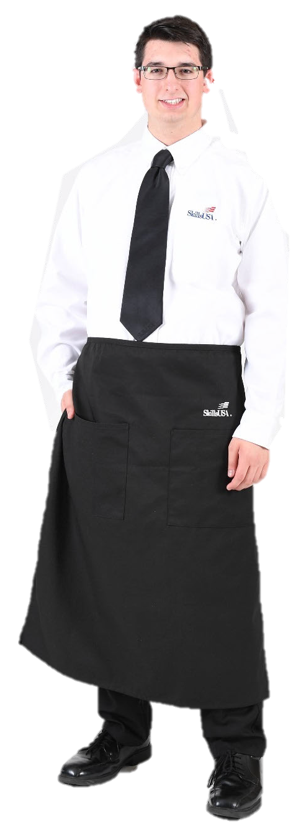

CLASS I: COMPETITION SPECIFIC — WELDING | WELDING FABRICATION
- Official SkillsUSA khaki long-sleeve work shirt (100% cotton as per OSHA regulations) Khaki pants (100% cotton as per OSHA regulations) OR khaki work shirt and pants Without SkillsUSA or other logos
- Black, brown, or tan leather work shoes

Note: Safety glasses must have side shields or goggles. (Prescription glasses may be used only if they are equipped with side shields. If not, they must be covered with goggles.)

